Problem 1: Log in System
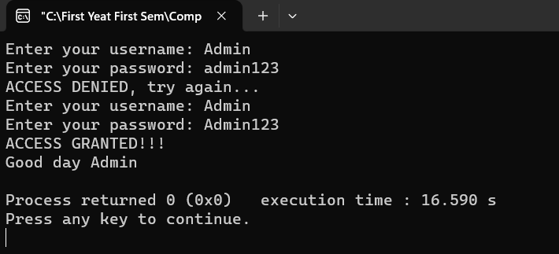
Here is my c++ code:
#include <iostream>
#include <string>

using namespace std;

int main() {
string username, password;

do {
cout << "Enter your username: ";
cin >> username;

cout << "Enter your password: ";
cin >> password;

if (username == "Admin" && password == "Admin123") {
cout << "ACCESS GRANTED!!!" << endl;
cout << "Good day Admin" << endl;
break;
} else if (username == "Guest" && password == "Guest123") {
cout << "ACCESS GRANTED!!!" << endl;
cout << "Good day Guest" << endl;
break;
} else if (username == "Secretary" && password == "Sec123") {
cout << "ACCESS GRANTED!!!" << endl;
cout << "Good day Secretary" << endl;
break;
} else {
cout << "ACCESS DENIED, try again..." << endl;
}
} while(true); // Repeat the loop until credentials are correct

return 0;
}
Problem 2: Ordering System
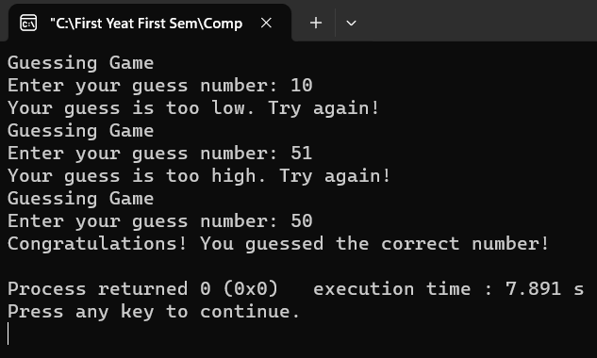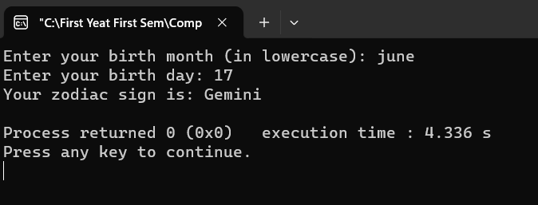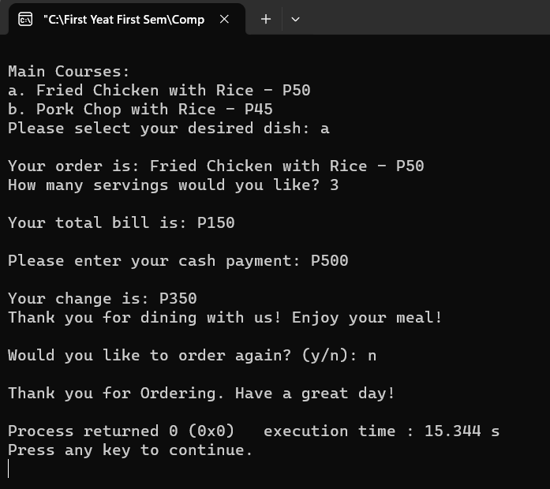
Here is my c++ Code:
#include <iostream>

using namespace std;

int main()
{
char option;
int quantity, totalAmount = 0;
string orderDetails;

do {
orderDetails = ""; // Reset order details for each order

// Display the main menu
cout << "\nWelcome to my ordering system!" << endl;
cout << "Please choose from my menu:" << endl;
cout << "1. Main Courses" << endl;
cout << "2. Desserts" << endl;
cout << "3. Beverages" << endl;
cout << "Enter your choice: ";
cin >> option;
system("cls");

// Process the selected option
switch (option) {
case '1': // Main Courses
cout << "\nMain Courses:" << endl;
cout << "a. Fried Chicken with Rice - P50" << endl;
cout << "b. Pork Chop with Rice - P45" << endl;
cout << "Please select your desired dish: ";
cin >> option;

switch (option) {
case 'a':
orderDetails += "Fried Chicken with Rice - P50";
totalAmount += 50;
break;
case 'b':
orderDetails += "Pork Chop with Rice - P45";
totalAmount += 45;
break;
default:
cout << "Invalid choice. Please try again." << endl;
return 1;
}

break;

case '2': // Desserts
cout << "\nDesserts:" << endl;
cout << "a. Chocolate Cake - P25" << endl;
cout << "b. Ice Cream - P50" << endl;
cout << "Please select your sweet treat: ";
cin >> option;

switch (option) {
case 'a':
orderDetails += "Chocolate Cake - P25";
totalAmount += 25;
break;
case 'b':
orderDetails += "Ice Cream - P50";
totalAmount += 50;
break;
default:
cout << "Invalid choice. Please try again." << endl;
return 1;
}

break;

case '3': // Beverages
cout << "\nBeverages:" << endl;
cout << "a. Coke - P18" << endl;
cout << "b. Sprite - P20" << endl;
cout << "Please select your refreshing drink: ";
cin >> option;

switch (option) {
case 'a':
orderDetails += "Coke - P18";
totalAmount += 18;
break;
case 'b':
orderDetails += "Sprite - P20";
totalAmount += 20;
break;
default:
cout << "Invalid choice. Please try again." << endl;
return 1;
}

break;

default:
cout << "Invalid choice. Please enter a valid option (1, 2, or 3): ";
return 1;
}

// Get quantity and calculate total amount
cout << "\nYour order is: " << orderDetails << endl;
cout << "How many servings would you like? ";
cin >> quantity;
totalAmount *= quantity;

// Display total bill
cout << "\nYour total bill is: P" << totalAmount << endl;

// Process payment
int cash;
cout << "\nPlease enter your cash payment: P";
cin >> cash;

if (cash >= totalAmount) {
int change = cash - totalAmount;
cout << "\nYour change is: P" << change << endl;
cout << "Thank you for dining with us! Enjoy your meal!" << endl;
} else {
cout << "Insufficient cash. Please try again." << endl;
return 1;
}

// Ask if the user wants to order again
cout << "\nWould you like to order again? (y/n): ";
cin >> option;
} while (option == 'y');

cout << "\nThank you for Ordering. Have a great day!" << endl;

return 0;
}

